[11:-10] (array([-12.07204427, 18.82788785]), array([[ 0.000248 , -0.00104426],

[-0.00104426, 0.00442864]])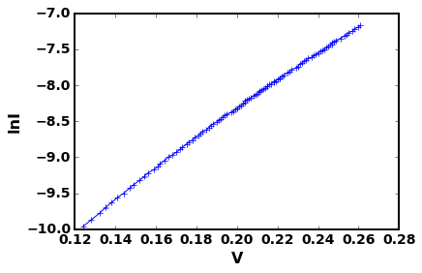

[12:-10](array([-12.07132866, 18.82489454]), array([[ 0.00024774, -0.00104307],

[-0.00104307, 0.00442303]])) 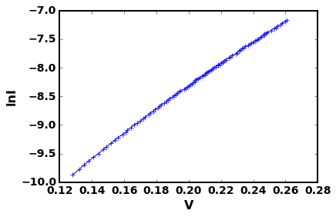

[13:-10] (array([-12.07059817, 18.82184779]), array([[ 0.00024732, -0.00104124],

[-0.00104124, 0.00441499]])) 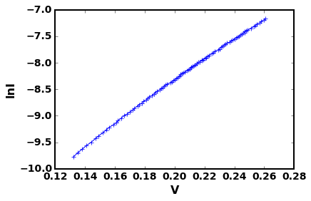

[14:-10] (array([-12.06971907, 18.81817976]), array([[ 0.00024638, -0.00103744],

[-0.00103744, 0.00439946]])) 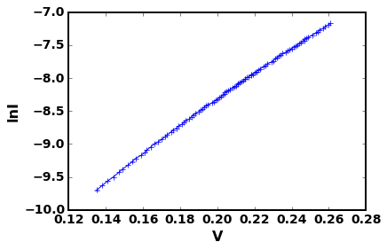

[15:-10] (array([-12.06856646, 18.81337053]), array([[ 0.00024502, -0.00103123],

[-0.00103123, 0.00437109]])) 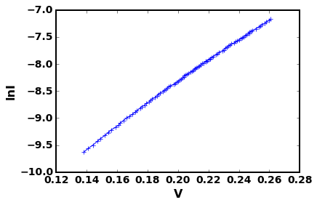

[16:-10] (array([-12.0668248 , 18.80611453]), array([[ 0.00024159, -0.00101712],

[-0.00101712, 0.00431246]])) 